**Front Page**  
**DIGISOL**

**Front Page Design:**  
Visual of two hands shaking — one representing IT Networking Products, the other labelled "India’s Digisol" in different Indian languages.

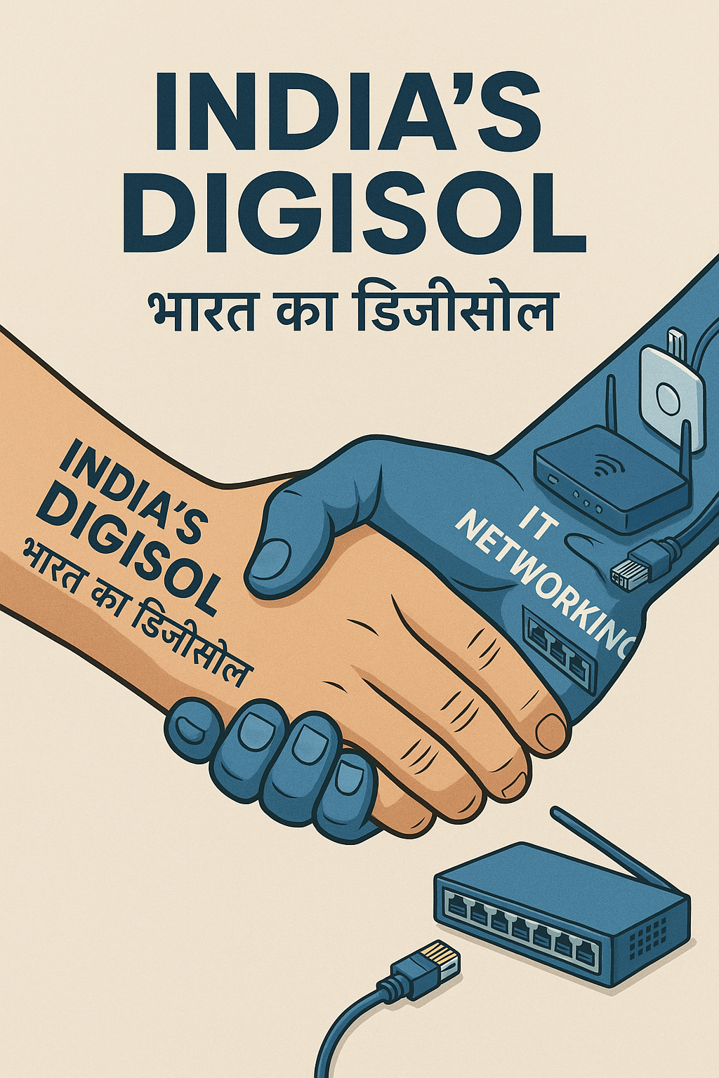

**

**DIGISOL ALLIANCE PARTNER PROGRAM**

**Page 2 AND 3:** ABOUT DIGISOL

* Digisol offering (four solutions)
* Why Digisol
* Certification
* Growing Customer base

Page 4 content: **About DAPP and DAPP related Logos**

**About DAPP:**

DIGISOL is founded by Mr. K. R. Naik who is known as the Father of Indian I.T Networking Industry, for establishing whole channel market for IT Networking products from Distributors to Retailers and also guiding all the partners who believed in his vision to make internet available across India.

Digisol Alliance Partner Program is to honour its partners by offering various assistance to help them achieve the best of the IT Networking opportunities.   
DIGISOL Alliance Partner Program (DAPP) offers exclusive benefits to DIGISOL partners including post-sales technical support, prioritized partner assistance, advance product replacement, technical & sales training, go-to-market toolkits, product roadmaps, access to marketing collaterals, and co-marketing opportunities.

**Under the program, DIGISOL will have following partners: (NEED GOOD LOGOS FOR EACH OF THEM LIKE MADE BELOW)**

* DIGISOL Premium Partner
* DIGISOL Connect Partner
* DIGISOL Valued Partner  
  (for channel business)

*And*

* DIGISOL National SI Partner
* DIGISOL Premier SI Partner
* DIGISOL Select SI Partner  
  (for project business)

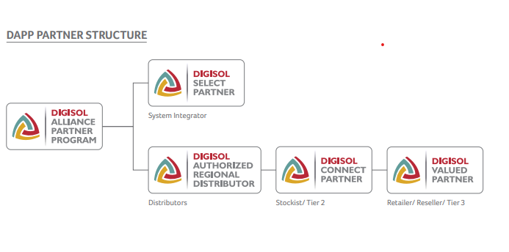

**Page: 5**

**DAPP consists of ‘Six – Tiered’ Partners in the following Categories:**

|  |  |  |  |  |  |  |
| --- | --- | --- | --- | --- | --- | --- |
| Partner Category | Partner Focus | | | | | |
|  | Presence | Market Segment | Value Add Address | Skill Availability | GTM Model |
| Digisol National SI Partner | National  Footprint | Enterprise  & Mid  Market | Service  Oriented  Projects | Multiple products  Solution designing  skills for Enterprise  & Mid-Market | Service oriented  vertical focused  technology  integration  business model |
|  |  | Application  Integration | Integration & SLA  delivery skills |  |
|  |  | Vertical  Solution  Design &  Implementation | Network Operation  Center |  |
|  |  | End to End  Network  Integration | Multiple Technology  specialization |  |
|  |  | Data Center  Implementation | Multiple Technology  certification |  |
|  |  | Multi-location  service  Offering |  |  |
|  |  | In-House  spare  inventory  for SLA delivery |  |  |
| Digisol Premier SI Partner | Regional /  Multi  Location  Presence | Mid  Market &  SMB | Mid-Size Service  oriented project | Multiple Technology  awareness | End to End IT  infrastructure  integration  business model |
|  |  | End to End Mid  Size Network  Integration | Solution designing  skill for Mid-Market  solution |  |
|  |  | Structured  Cabling Project  Implementation | Multiple Technology  Specialization |  |
|  |  | Multi location  Service offering | Multiple Technology  Certification |  |
|  |  | In House  Sparee  Maintenance  for SLA delivery |  |  |
| Digisol Select SI Partner |  |  |  |  |  |
|  |  |  |  |  |
|  |  |  |  |  |
| Digisol Premium Partner | Regional /  City based  Presence | SMB &  SMEs | Network  Integration for  SMB | Basic Product  solution specific  Skills | SMB focused  Technology  integration  business model |
|  |  | Structured  Cabling Project  Implementation | In-house Presales  & Post Sales skills |  |
|  |  | Networking pie  address along  with PC / Server  Laptop sale |  |  |
| Digisol Connect Partner | Location  specific /  City based  Presence | SMB & SOHO | Market address  through multiple  partners for SMB  projects & SOHO  requirement | Basic Product  specific skills | Multi product,  multi partner  reselling  business model |
| Digisol Valued Partner | Location  specific /  City based  Presence | SOHO | Market address for SOHO  requirement | Basic Product  specific skills | Multi product,  multi partner  reselling  business model |

**Pre-requisite for DAPP:**

|  |  |  |  |  |  |  |
| --- | --- | --- | --- | --- | --- | --- |
| **Prerequisite** | **DNSI** | **DPSI** | **DSSI** | **DPP** | **DCP** | **DVP** |
| Investment in skill development |  |  |  |  |  |  |
| * Enhance the selling skills of sales personnel. | Yes | Yes |  | Yes | Yes |  |
| * Provide total solutions through in-house Specialization | Yes  (1 per region) | Yes (Minimum 2) |  | Yes (Minimum 1) |  |  |
| * Maintain an in-house Product Certified Engineer - 1 per region | Yes  (1 per region) | Yes (Minimum 2) |  | Yes (Minimum 1) |  |  |
| Proactive Positioning of DIGISOL solutions |  |  |  |  |  |  |
| * Highlight advantages and enforce DIGISOL’s product & services differentiation | Yes | Yes |  | Yes | Yes | Yes |
| * Adopt and use designs as per DIGISOL’s standards | Yes | Yes |  | Yes | Yes | Yes |
| * Counter competition with respect to technology superiority | Yes | Yes |  | Yes | Yes | Yes |
| Business plan sign-off |  |  |  |  |  |  |
| * Total agreement on business/ revenue potential + be target specific | Yes | Yes |  | Yes | Yes |  |
| Periodical Process driven review |  |  |  |  |  |  |
| * Quarterly review of targets Vs Achievements and re-align strategy to meet shortfall | Yes | Yes |  | Yes | Yes |  |
| Permission to DIGISOL distributor to produce sales report |  |  |  |  |  |  |
| * A tracking system to evaluate Performance At regular intervals / check and regulate deviations in achievements | Yes | Yes |  | Yes | Yes |  |
| Revenue Target Achievement |  |  |  |  |  |  |
| * Evaluating volume Vs value - use as Guideline | Yes | Yes |  | Yes | Yes |  |
| Minimum DIGISOL business value Annually | 1 crore | 20 lakhs |  | 2 crores | 20 lakhs | 5 lakhs |
| Partner end customer Network | Yes | Yes |  | Yes |  |  |
| Channel customer network |  |  |  | Yes | Yes | Yes |

**DAPP Deliverables**

**DAPP:**

**DAPP Website**

* The DAPP program is now supported by a dedicated website to enhance the partner experience.
* The website is built on values of innovation and commitment.
* It serves as a tool to help partners grow their business, increase revenue, and build strong ties with DIGISOL.
* The existing DAPP program already rewards partners for their contribution with marketing and sales support.
* Now, it’s being taken further via a dedicated DAPP website, aimed at better engagement.
* Partners can access resources, marketing tools, schemes, training, and much more through this platform.

Website Link: *(To be added)*

**DAPP WEBSITE BENEFITS**

* Access all marketing materials online — EDMs, social media posts, brochures, product videos, press releases, etc.
* Support for products EDMs with partner’s logo
* Get regular scheme updates and reminders.
* Mobile-optimized for easy use.
* Get authorized DIGISOL Partner status and certificate.

**Stepwise DAPP Partner Registration Process**

* Partner visits the website.
* Clicks on “Apply Now” under “Become A DIGISOL Partner”.
* Fills and submits the registration form with valid company details and a soft copy of their PAN card.
* Receives an acknowledgement email confirming the receipt of the registration request.
* Upon backend verification, receives an approval email along with an e-certificate for their applicable partner type.
* Gains access to website resources post-verification.
* DIGISOL reserves the right to reject registrations with incorrect information.

**DITT: *(Link to be provided)***

**DAPP Deliverables:**

|  |  |  |  |  |  |
| --- | --- | --- | --- | --- | --- |
| **Pre-requisite** | **DNSI** | **DSSI** | **DPP** | **DCP** | **DVP** |
| Use of Partner Logo | Yes | Yes | Yes | Yes | Yes |
| Monthly " DIGISOL Partner Pulse" Newsletter | Yes | Yes | Yes | Yes | Yes |
| Product Lauch Kit | Yes | Yes | Yes | No | No |
| Access to DIGISOL Specialist Speaker | Yes | Yes | Yes | No | No |
| Access to DIGISOL Merchandising Material | Yes | Yes | Yes | Yes | Yes |
| Assigned DIGISOL Account Manager | Yes | Yes | Yes | Yes | No |
| Staff Incentive Programs and Special Promotions | Yes | Yes | Yes | No | No |
| Access to Internal DIGISOL Sales Support Representative | Yes | Yes | Yes | Yes | Yes |
| Priority Invitations to DIGISOL Workshops and Trainings | Yes | Yes | Yes | Yes | Yes |
| Participation in DIGISOL End User Events* | - | - | - | - | - |
| Joint Marketing Funds | No | No | Yes | No | No |
| Priority Technical Support | Yes | Yes | Yes | Yes | Yes |
| Leads referrals from DIGISOL | Yes | Yes | Yes | Yes | Yes |
| Listing on ‘Where to Buy’ website | No | No | Yes | No | No |

Notes:

*Based on event type

**Terms & Conditions**

1. Eligibility for partners under DIGISOL Partner Program is subject to completion of prerequisite criteria
2. DIGISOL Partner eligibility is valid for one year or for particular financial year- whichever is early
3. DIGISOL Partnership is subject to quarterly business review with each partner
4. NFR demo Kit is available against submission of NFR request form through DIGISOL Business Development / Account Manager. NFR Kit is not to be sold for 3 months from the date of purchase. Only one product/ technology per quarter will be allowed under NFR Kit.
5. Any rebate/ claims are subject to verification of necessary documents. (Documentation requirement will be as per DIGISOL policy time to time)
6. Proof of purchase from DIGISOL Premium Partner (Authorized Distributors) or DIGISOL Connect Partner (Stockists) will be considered valid for any claims for Digisol National and Select SIs and Digisol Valued Reseller.
7. DIGISOL will process DIGISOL Partner Rebate Claims based on the schemes periodically. (as per terms and conditions mentioned in schemes)
8. DIGISOL reserves the right to verify Rebate Claims with any relevant Premium partner prior to the Rebate being paid
9. DIGISOL reserves the right to terminate and/or make changes to the Programme at any time and will provide reasonable notice of changes or termination
10. “WHERE to BUY” listing on the DIGISOL Is subject to meeting certain criteria which can be informed through your Account Manager
11. Merchandising product may be available to you subject to availability. You may request merchandising materials via the Merchandising Request Form available from the DIGISOL Partner website. Merchandising request will have its own terms and conditions.
12. Staff Incentives and Promotions are subject to their own terms and conditions which will be made available prior to the time of incentive/ promotion launch and are dependent on the Partner's Company Policies
13. DIGISOL Partners are eligible for Marketing Co-op funds. These funds are provided as a way of assisting these Partners in marketing DIGISOL products. To use these funds the Partner will be required to adhere to its own terms and conditions which will be available on the website.

**Last Page:**

Images of the Plant and R&D Centre, along with the addresses of the Head Office, R&D Centre, and Plant. Also, include the official social media handles.